FOR IMMEDIATE RELEASE:
Month DD, YYYY

Flex Family Health Breaks Ground on New Facility, Expanding a Bold Vision for Healthcare in Billings
Billings, MT — Flex Family Health will officially break ground on a new, purpose-built clinic facility on Monday, February 16, 2026 at 10:00 a.m. at 3549 Gabel Road in Billings — marking a major milestone not only for the clinic, but for the future of healthcare delivery in the region.
Founded on the belief that primary care should be accessible, relationship-driven, and transparent, Flex Family Health has steadily grown as individuals, families, and employer groups seek alternatives to traditional healthcare models. The new facility represents a long-term investment in that mission — and in the Billings community.
“This building is more than brick and mortar,” said Cole Whitmoyer, Owner of Flex Family Health. “It represents our conviction that healthcare can be simpler, more personal, and more affordable. We are building a space that allows us to deepen relationships, expand access, and serve our community for decades to come.”
The new clinic will provide expanded clinical capacity, enhanced patient experience, and room to continue partnering with local employers who are seeking sustainable, patient-centered healthcare solutions for their teams. The facility is intentionally designed to support growth while preserving the personalized care model that defines the practice.
Since its founding, Flex Family Health has worked to remove barriers to care, increase price transparency, and strengthen continuity between patients and providers. This expansion signals both the success of that model and the growing demand for healthcare solutions rooted in trust and accessibility.
Community members, patients, local leaders, and business partners are invited to attend the groundbreaking ceremony.
Event Details:
Groundbreaking Ceremony
Monday, February 16, 2026
10:00 a.m.
3549 Gabel Road
Billings, MT
Rendering of the future Flex Family Health: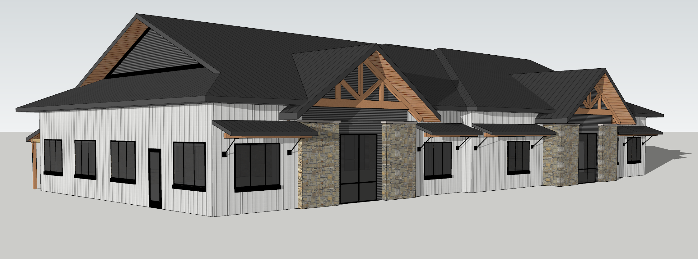
For more information about Flex Family Health and its services, please visit www.flexfamilyhealth.com or contact cole@flexfamilyhealth.com.
Contact:
Name
Title
P: (406) 000-0000
F: (406) 000-0000
Email

